DISTINCT TUMOR GENOMIC SIGNATURES
UNDERLIE CANINE MACROPHAGE POLARIZATION

Rachel V. Brady, Sunetra Das, Dawn L. Duval, Kristen B. Farrell, Eric P. Palmer, Douglas H. Thamm

Funding Statement: This work was supported by the NIH Ruth L. Kirschstein Institutional National Research Service Award (NRSA) Training Grant T32OD01043, awarded through Colorado State University, and a gift from The Anschutz Foundation.

Data Access Statement: The datasets used and analyzed during the current study are available from the corresponding author on reasonable request.

Conflict of Interest Declaration: The authors declare no potential conflicts of interest.

Acknowledgements: The authors thank Rupa Idate for extensive work in maintaining and validating cell lines, and Laurel Haines for generously sharing her expertise on exosome biology.

INTRODUCTION
The tumor microenvironment (TME) drives cancer progression. The TME has documented roles in tumor growth and metastasis, as well as in treatment response and resistance.¹ Many new cancer therapies are TME-centric rather than cancer cell-centric, highlighting the importance of improving the understanding of the TME.² There is major variability in the TME, both between and within tumor types.³ Advancements in single-cell sequencing and transcriptomic techniques have identified immune cell compositions within the TME that are common across cancer types and multiple TME subtypes within a single tumor type.⁴ This variability contributes to the mixed success of immunotherapies, and makes patient stratification an evolving problem.⁵
The TME is shaped by many factors, only some of which are well-understood. Tumor histopathology can affect a broad range of pathological patterns. For example, metastatic melanoma and non-small cell lung cancer (NSCLC) are commonly treated with immune checkpoint inhibitors. However, many patients fail to achieve sustained benefits from these therapies, even with newer combination approaches, partly because of the heterogeneity of the TME.^{6,7} Certain mutations in key cancer-related genes have been shown to affect the TME. Loss of the tumor suppressor gene phosphatase and tensin homolog (PTEN) is associated with T-cell exclusion and immunotherapy resistance in many cancer types.⁸ Similarly, gain-of-function mutant p53 has multiple immunosuppressive and prometastatic effects in the TME.⁹ Patient factors, such as weight and age, influence the TME, partly due to changes in cellular metabolism and inflammation.^{10,11} The metabolic state of the TME drives variability, as changes in glucose, amino acid, and lipid availability affects crosstalk between immune and cancer cells.¹² Finally, epigenetic regulation of the TME immune environment takes place.¹³ The repressive polycomb-group enzyme enhancer of zeste homolog 2 (EZH2) can methylate and silence promoters of T-cell recruiting chemokines, leading to a “cold” TME, lacking in cytotoxic T-cell infiltration.¹⁴ Cancer therapy also applies pressure on the TME, resulting in evolution over time.¹ Together, these factors make the TME a formidable barrier to effective immunotherapy.
Tumor-associated macrophages (TAMs) are the most abundant immune cells in the TME of most solid tumors, and comprise a markedly heterogeneous group with diverse phenotypes and roles.⁴ They are currently being investigated as promising therapeutic targets, biomarkers, and diagnostic imaging markers for cancer. TAMs are usually described as having an “M2-like” or immunosuppressive phenotype, although the dichotomous categorization of macrophages into M1 or M2 phenotypes is overly simplistic. TAMs can simultaneously express gene signatures from multiple phenotypes; several phenotypes have been documented in single-cell sequencing studies.¹⁵ However, most TAM phenotypes promote tumor progression in several ways. They do this by driving angiogenesis, facilitating tumor cell invasion and metastasis, and enhancing immune evasion.¹⁵ Many TAM-targeted therapies are in early stage clinical trials in humans, and only a handful of these have been explored in canine cancer.¹⁶
Canine cancers offer a unique translational bridge between preclinical models and clinical trials. Dogs have become a frequently used model for studying human cancer because of the similarities in their spontaneously occurring tumors, biology, and environmental exposure.¹⁷ In particular, the canine and human immune systems are more closely aligned than the murine system, and spontaneous canine tumors have evolved immune avoidance strategies during development, similar to those employed by human tumors.^{17,18} When canine clinical trials are incorporated into the preclinical drug discovery pathway, there are distinct advantages in terms of cost and time compared with standard drug discovery. Several FDA-approved cancer drugs have been discovered and approved through the parallel efforts of human and veterinary researchers.¹⁹
Despite major advances in immune-based therapies, only a few biomarkers can accurately predict responses in cancer patients.²⁰ Therefore, there is a clear need for TME-based biomarkers. Therefore, in this study, we introduce a novel method for TME biomarker discovery. We aimed to correlate canine macrophage phenotypes after polarization with tumor-conditioned media (TCM) with mutational and gene expression data from canine cancer cell lines. We hypothesized that canine cancer cell lines would have varying abilities to polarize primary macrophages, as measured by their secretory products, irrespective of their tumor of origin. We also hypothesized that those with the strongest ability to polarize macrophages would have similar differentially expressed genes (DEGs), which may be useful as biomarkers or therapeutic targets.
MATERIALS AND METHODS
Cell line maintenance and validation
All cell lines were maintained in complete growth medium composed of Dulbecco’s modified essential medium (DMEM, Gibco, Grand Island, NY) or Roswell Park Memorial Institute medium (RPMI, Gibco, Grand Island, NY) supplemented with 1× MEM vitamin solution (Corning, Corning, NY), 2 mM L-glutamine (Corning), 1 mM sodium pyruvate (Corning), and 10% or 20% fetal bovine serum (FBS, Peak Serum, Bradenton, FL) (D10/R10/R20). All cells were grown in a 37°C humidified atmosphere with 5% CO₂ and serially passaged by trypsinization or density gradient centrifugation. Cell lines were validated to be of canine origin using multispecies multiplex polymerase chain reaction (PCR) as described and validated as mycoplasma-free.²¹ Research Resource Identifiers (RRIDs) of cell lines used in this study are provided in Supplementary Table 1.
Generation of standardized TCM
Aliquots of adherent cells were thawed from liquid nitrogen storage and seeded into T-150 flasks in D10. The cells were allowed to grow to 80% confluence or for a minimum of 24 h if they had already reached 80% confluence. The cells were then trypsinized and 10⁶ cells were re-seeded in the same T-150. They were allowed to grow to 80% confluency, at which point the medium was removed and 9 mL of fresh D10 was added. 24 h later, the medium was collected, spun to remove all cells, and stored as standardized TCM. The cells were then trypsinized and counted. After all TCM from adherent cell lines was collected, the median number of cells at the time of TCM harvesting was calculated. For suspension cell lines, aliquots were seeded into T-150 cells in R10 medium. After 48 h, the cells were counted and 10⁶ cells were seeded in the same T-150. After 2-4 days, the cells were counted again, and 60% of the average number of adherent cells at the time of TCM harvest was seeded into T-150 with 9 mL of D10. After 24 h, the medium was collected as TCM as described above, and the cells were counted.
Primary macrophage culture
Canine peripheral blood mononuclear cells (PBMCs) were isolated by density-gradient centrifugation under an approved protocol and plated in R20 for monocyte adherence overnight. Adherent monocytes were then differentiated for 7 days in R20 and 40 ng/µL monocyte colony-stimulating factor (M-CSF). For polarization, macrophages from three donors were treated 24 h with either 70% TCM/30% R10 or control medium (70% D10/30% R10), washed three times with PBS, replenished with R10 for another 24 h, and supernatants collected; cell-free wells processed in parallel confirmed complete TCM removal by the washes. The donor details are provided in Supplementary Table 2 and additional details are provided in Supplementary Methods.
Cytokine analysis of cell supernatants
The concentrations of c–c motif chemokine ligand 2 (CCL2), vascular endothelial growth factor (VEGF), transforming growth factor-beta (TGF-β), tumor necrosis factor-alpha (TNF-α), and CCL3 were measured using individual enzyme-linked immunosorbent assay (ELISA) kits (see Supplementary Methods). In parallel, an immunology multiplex assay (MILLIPLEX® canine cytokine/chemokine panel) was run on a Luminex MagPix with xPONENT® software. Eight analytes fell below the quantification limits and were excluded, and CCL2 levels exceeded the assay range, necessitating 150x dilution for accurate ELISA measurement. Additional details are provided in Supplementary Methods.
Normalization of results
Absolute values from the ELISAs and the multiplex panel were normalized. As the data had a non-normal distribution, a modified z-score was calculated for each analyte (given by modified z-score = [0.6745(the data point – the median of the dataset)] / the median absolute deviation of the dataset).²² The modified z-score was used to create a rank order of cancer cell lines for each analyte, with a high modified z-score indicating that TCM from a cell line stimulated a high relative amount of the secretory product from macrophages, and a low modified z-score indicating that TCM from a cell line stimulated a low relative amount of the secretory product. The modified z-scores were correlated between the analytes and with previously published mutational and phosphorylation data.²³
RNA-sequencing and analysis
Bulk-RNA sequencing (RNA-seq) of the canine cell lines used in this study was previously performed by investigators at the Flint Animal Cancer Center (FACC).²⁴ Spearman’s rank correlations between each gene’s expression (transcripts per million [TPM] and removed unwanted variation using control genes [RUVg]‐normalized) and cytokine modified Z-scores were computed. Differential expression between “high” and “low” macrophage stimulators (top/bottom modified Z-score quartiles) was performed in DESeq2 on the filtered raw count matrix (excluding genes with ≤ 3 counts or present in fewer than half the analyzed samples). Genes with absolute log base 2 fold change (|log₂FC|) ≥ 1 and Benjamini–Hochberg (BH)-adjusted p ≤ 0.05 were deemed significant. Pre-ranked GSEA was run against molecular signatures database (MsigDB) Hallmark (H), Curated (C2), Oncogenic (C6) and Immunologic (C7), with BH-adjusted p ≤ 0.25 considered significant. Finally, CCL3 transcript counts were extracted from public datasets (NCBI BioProject, accession numbers PRJDB11462, PRJEB36828, and PRJDB17594). Additional details are provided in Supplementary Methods.
Exosome depletion and validation study
Seven of the top VEGF-stimulating cell lines were selected, and aliquots of their TCM were thawed and split into three fractions of equal volume: whole TCM, exosome-depleted TCM (Amicon Ultra centrifugal filters; Millipore Sigma, #UFC210024), and an exosome-only fraction. Exosome concentrations were quantified by tunable resistant pulse sensing with a nano-pore 150 set to a ~47 nm stretch and measured against standardized calibration particles (qNano Gold, Izon; #NP100, #CPC200). Macrophages from three canine donors were differentiated for 7 days, treated with each condition (TCM from seven lines × 3 fractions each), washed, and assayed for VEGF in the supernatants. For exosome-cargo interrogation, exosome-only fractions were lysed in 5x RIPA buffer as previously described (equal volume to the exosome-depleted fraction) before VEGF measurement.²⁵
To replicate the initial findings, fresh TCM was generated from two high-VEGF stimulating lines (Nike, Parks) and two low-VEGF stimulating lines (CLL1390, 1771), along with four new lines selected based on MVB12A expression. Macrophages from three new donors were treated with these eight TCM and supernatants were collected as described above for VEGF ELISA.
CCL3 stimulation
Detailed methods for CCL3 knockdown are provided in Supplementary Methods. Macrophages from three new canine donors were stimulated in triplicate with a range of recombinant canine CCL3 concentrations for 24 h (Novus Biologicals, Centennial, CO, #NBP3-11065). Supernatants were assayed for TNF-α by ELISA and corrected for cell loss noted at higher CCL3 concentrations. DH82 cells underwent CCL3 knockdown to produce fresh TCM from wild-type (WT), knockdown (KD), and non-targeting control (NTC) cells. Donor macrophages were treated with each TCM in triplicate for 24 h, washed, and their supernatants were analyzed for CCL3 expression by ELISA.
Statistical Analysis
Analyses and data visualization were performed using GraphPad Prism (RRID:SCR_002798) and R version 4.3.1 (RRID:SCR_001905).²⁶ Normality was assessed using the Shapiro–Wilk test, and data are reported as mean ± SEM or median (range). Two-group comparisons used unpaired two-tailed t-tests with Welch’s correction if needed), or the Wilcoxon rank-sum test for non-normal data. For three or more groups, one-way analysis of variance (ANOVA) was used when assumptions were met and the Kruskal–Wallis test when they were not. Overrepresentation analysis used 5,000-permutation testing with a fixed random number generator seed and BH adjustment. Intraclass correlation coefficients (ICCs) were used to quantify the inter-donor variability in cytokine secretion, and likelihood ratio tests were used to assess the statistical significance of donor effects. Correlations were evaluated using Spearman’s rank correlation, linear regression, or linear mixed-effect models (donor as random effects). Where applicable (e.g., correlations with mutational or phosphorylation status), p-values were adjusted for multiple testing using the BH false discovery rate (FDR) procedure, with unadjusted values reported for exploratory findings. Significance was set at p < 0.05, unless otherwise stated.

RESULTS
Classification and correlation of macrophage secretions
We quantified macrophage-secreted cytokines and chemokines in 25 canine cancer cell lines following TCM treatment. The average cell count at time of TCM harvest was 11.04 x 10⁶, ranging from 4.6 x 10⁶ to 20.04 x 10⁶ cells. There were no significant differences in the average cell count across the tumor types (see Supplementary Figure 1). Of the 15 analytes measured, seven were consistently above the detection threshold and included CCL2, IL-8, IL-10, KC-like, TNF-α, TGF-β, and VEGF. Significant inter-donor variability was observed for most of the cytokines. CCL2 and VEGF showed the greatest variability across donors, consistent with the wide dynamic range of macrophage secretion responses and high ICCs. KC-like (p = 0.055) exhibited a relatively high ICC value, indicating a more consistent response across donors. The descriptive statistics, ICCs, and corresponding p-values for the analytes are listed in Table 1. The modified z-scores for each analyte are shown in Figure 1.
Table 1. Analytes included for further analysis. Data are expressed as modified z-scores. A modified z-score of +1.0 indicates the measurement lies one median absolute deviation (MAD) above the median, of -1.0 indicates one MAD below. Interclass correlation coefficients (ICCs) represent the fraction of residual variance after accounting for treatment effect attributable to donor identity and the corresponding p-value from a likelihood-ratio test comparing models with and without donor as a random effect. Min = minimum, Max = maximum.
Analyte | Median | Min | Max | Range | ICC | p-value
VEGF | 0.8998 | -0.7566 | 3.4840 | 4.2410 | 0.614 | <0.001
TNF-α | 0.4402 | -0.6415 | 16.020 | 16.660 | 0.182 | 0.002
IL-10 | 0.4153 | -0.5104 | 39.730 | 40.240 | 0.115 | 0.028
CCL2 | 0.1410 | -0.1905 | 0.7910 | 0.9815 | 0.754 | <0.001
IL-8 | 0.1068 | -0.7979 | 1.7820 | 2.5800 | 0.209 | <0.001
KC-like | -0.0092 | -1.4630 | 2.4330 | 3.8950 | 0.096 | 0.055
TGF-β | -0.0014 | -0.5611 | 1.194 | 1.755 | 0.628 | <0.001
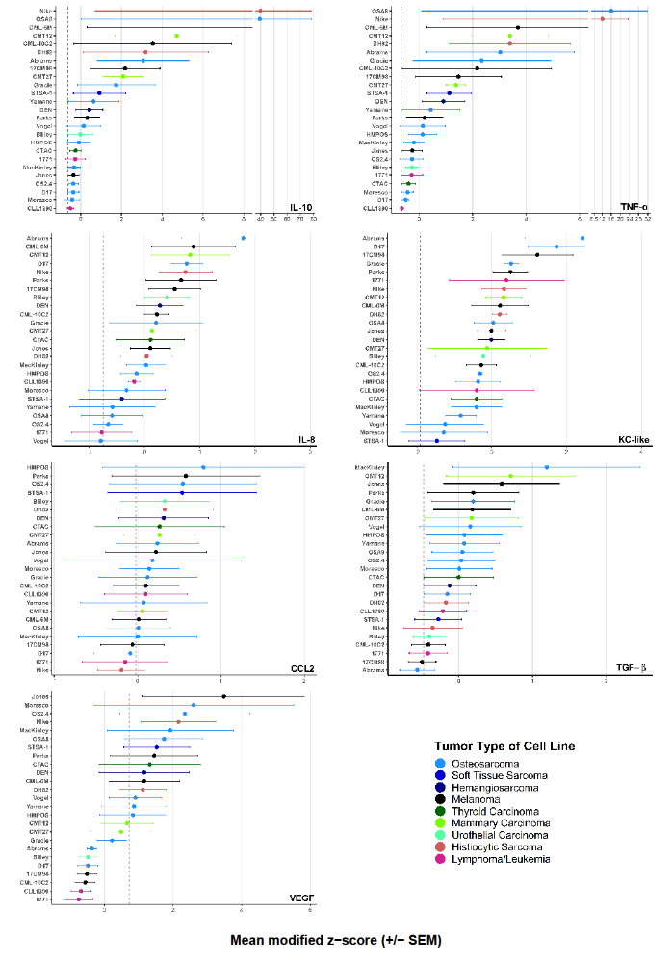 Figure 1: Modified z-scores of each analyte. Mean modified z-score for each cytokine secreted by donor macrophages, ranked in descending order, color-coded by tumor type. Vertical dotted line represents the mean modified z-score of control macrophages from the same 3 donors. Data are mean +/- standard error of the mean (SEM); n=3. (Higher quality version attached separately).

The raw values for each donor are shown in Supplementary Figure 2. Importantly, neither the cell number at the time of TCM harvest nor the tumor type that originated the cell lines significantly affected any analyte level, indicating that the results were not driven by differences in cell density during TCM collection or by the tumor type of the cells (Supplementary Table 3 and Supplementary Figure 3).
Two pairs of cytokines were significantly correlated with each other on adjusted p-value, most strongly with IL-10 and TNF-α (Figure 2). This would mean, for example, that TCM that stimulated macrophages to secrete IL-10 at relatively high levels was likely to also stimulate macrophages
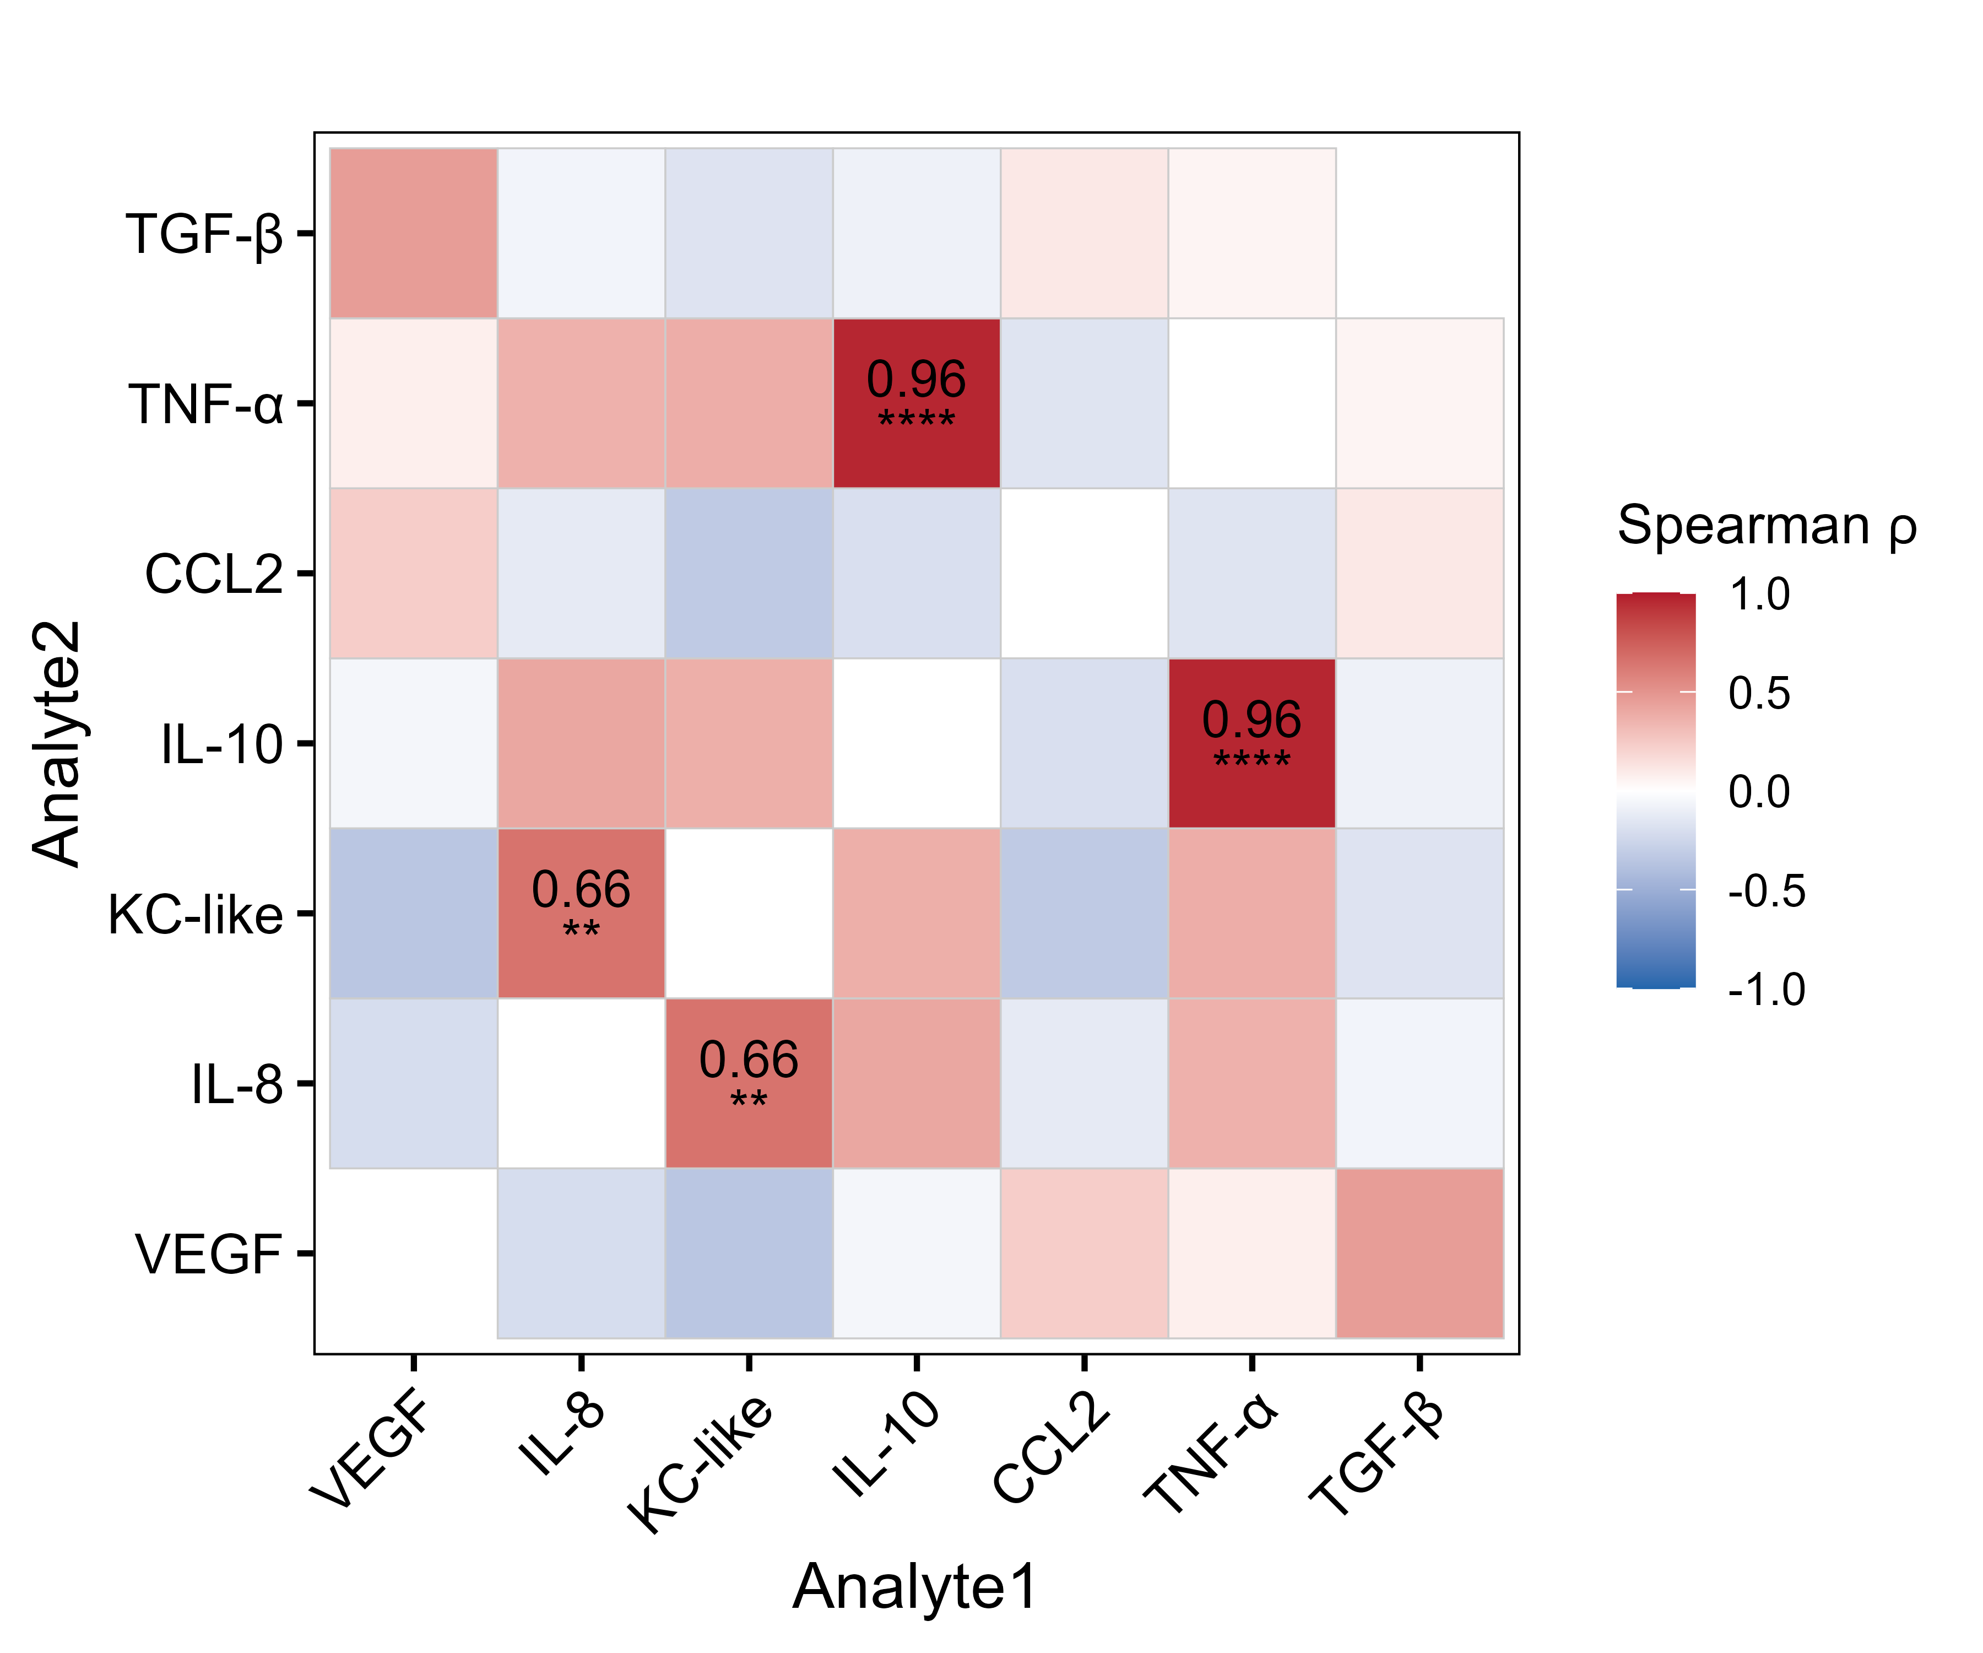
Figure 2: Spearman correlation heatmap of cytokine secretion. Each tile is colored by the Spearman ρ value (red = positive correlation, blue = negative correlation; scale bar at right). Statistically significant correlations false discovery rate correction for multiple comparisons are annotated: ** p < 0.01, **** p < 0.0001.

to secrete relatively high levels of TNF-α. There were no overrepresented cell lines or tumor types in the top or bottom quartiles across all analytes based on the adjusted p-values from permutation testing, although cell line 1771 (a B-cell lymphoma) trended towards overrepresentation in the bottom quartiles (adj. p = 0.064). Investigators at the FACC previously performed whole-exome sequencing on over 30 canine cell lines, providing mutational status and classifying phosphorylated protein kinase B (pAKT) and extracellular signal-regulated kinase (pERK) as active, constitutive, or low in 23 cell lines used in this study.²³ Therefore, we next looked for correlations between our data and the mutational and phosphorylation status. Although none of the results remained significant after correction for FDR, there were two findings that trended towards significance on adjusted p-value. TCM from cell lines that had two or more driver mutations tended to stimulate higher TGF-β (adj. p = 0.075), and TCM from cell lines that had active pAKT tended to stimulate higher levels of CCL2 (adj. p = 0.068 when compared to constitutive pAKT).
Canine cancer cell lines capable of potent polarization have relevant DEGs and pathways
Investigators at FACC have previously performed RNA-seq on 23 of the 25 cell lines used in this study (excluding Vogel [osteosarcoma] and CMT27 [mammary carcinoma]).²⁴ Therefore, we performed Spearman’s rank correlation analysis between the modified z-scores of each cytokine and available RNA-seq data. Using Spearman’s correlation between TPM‐normalized expression and VEGF-modified Z‐scores, we identified two genes whose expressions were strongly associated with VEGF secretion. First, multivesicular body subunit 12A (MVB12A, ρ = 0.817, q = 0.038) was upregulated in the high VEGF-stimulating cell lines. MVB12A is a key component of the endosomal sorting complex required for transport I (ESCRT‐I) that regulates exosome biogenesis.²⁷ Second, an unannotated Ensembl ID ENSCAFG00000024217 (ρ = 0.813, q = 0.038). Orthology analysis using HUGO Gene Nomenclature identified this as trafficking protein particle complex subunit 5 (TRAPPC5), a subunit of the TRAPP complex and also involved in vesicular trafficking.^{28,29} Both findings suggest a potential mechanistic link between the tumor cell vesicle/exosome pathways and macrophage VEGF release (Figure 3). All correlation results are provided in the Supplementary Table 4.
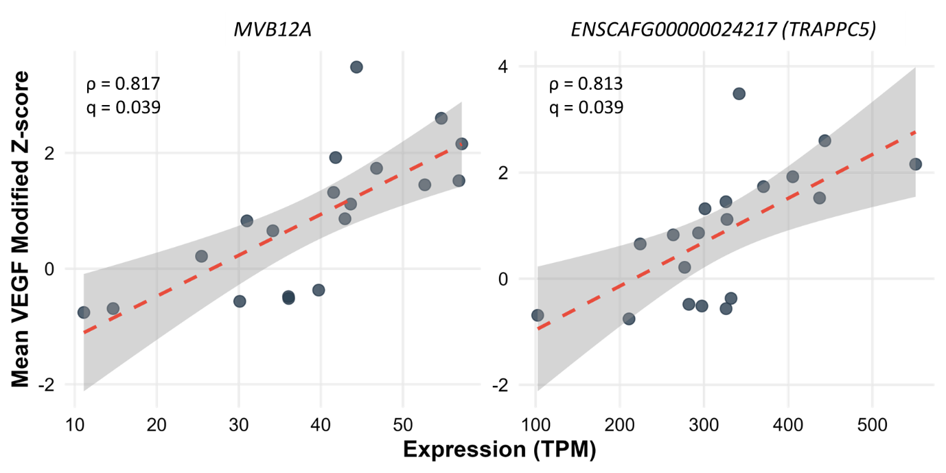
Figure 3: Spearman’s correlation between gene expression and VEGF response. Scatter‐plots showing the relationship between TPM‐normalized RNA-seq expression of MVB12A (left panel) and TRAPPC5 (ENSCAFG00000024217; right panel) versus mean VEGF modified Z-scores. Dashed red lines depict the linear regression trend with 95% confidence bands shaded in grey; annotations show each gene’s Spearman ρ and q-value.

We also performed pairwise differential gene analysis, in which we established “high” and “low” stimulator groups for each analyte between the top and bottom quartiles of the modified z-scores. Statistical analysis showed significant differences between the high and low stimulator groups for all the analytes (Supplementary Table 5). IL-8 and KC-like had a low number of differentially expressed genes (DEGs; 3 each), whereas the remainder of the cytokines had between 10 and 60 DEGs between the groups (Figure 4). A positive correlation indicates higher gene expression with higher relative secretion from macrophages (higher modified z-score), whereas a negative correlation indicates higher gene expression with lower relative secretion from macrophages (lower modified z-score). Across all high-stimulator cell lines, relevant upregulated DEGs included markers of macrophage activation and recruitment (CSF1R, CCL7, STAB1, ADAM8, CXCL14, IL12A), epithelial-to-mesenchymal transformation (SNAI1, SEMA7A), extracellular matrix remodeling (COL6A3) and metabolic reprogramming (GFPT2, SMPDL3A). Relevant downregulated DEGs included markers of immune surveillance (LAPTM5, CTSS) and cell adhesion (SEPTIN1, ACTA2). A full list of DEGs is provided in Supplementary Table 6.
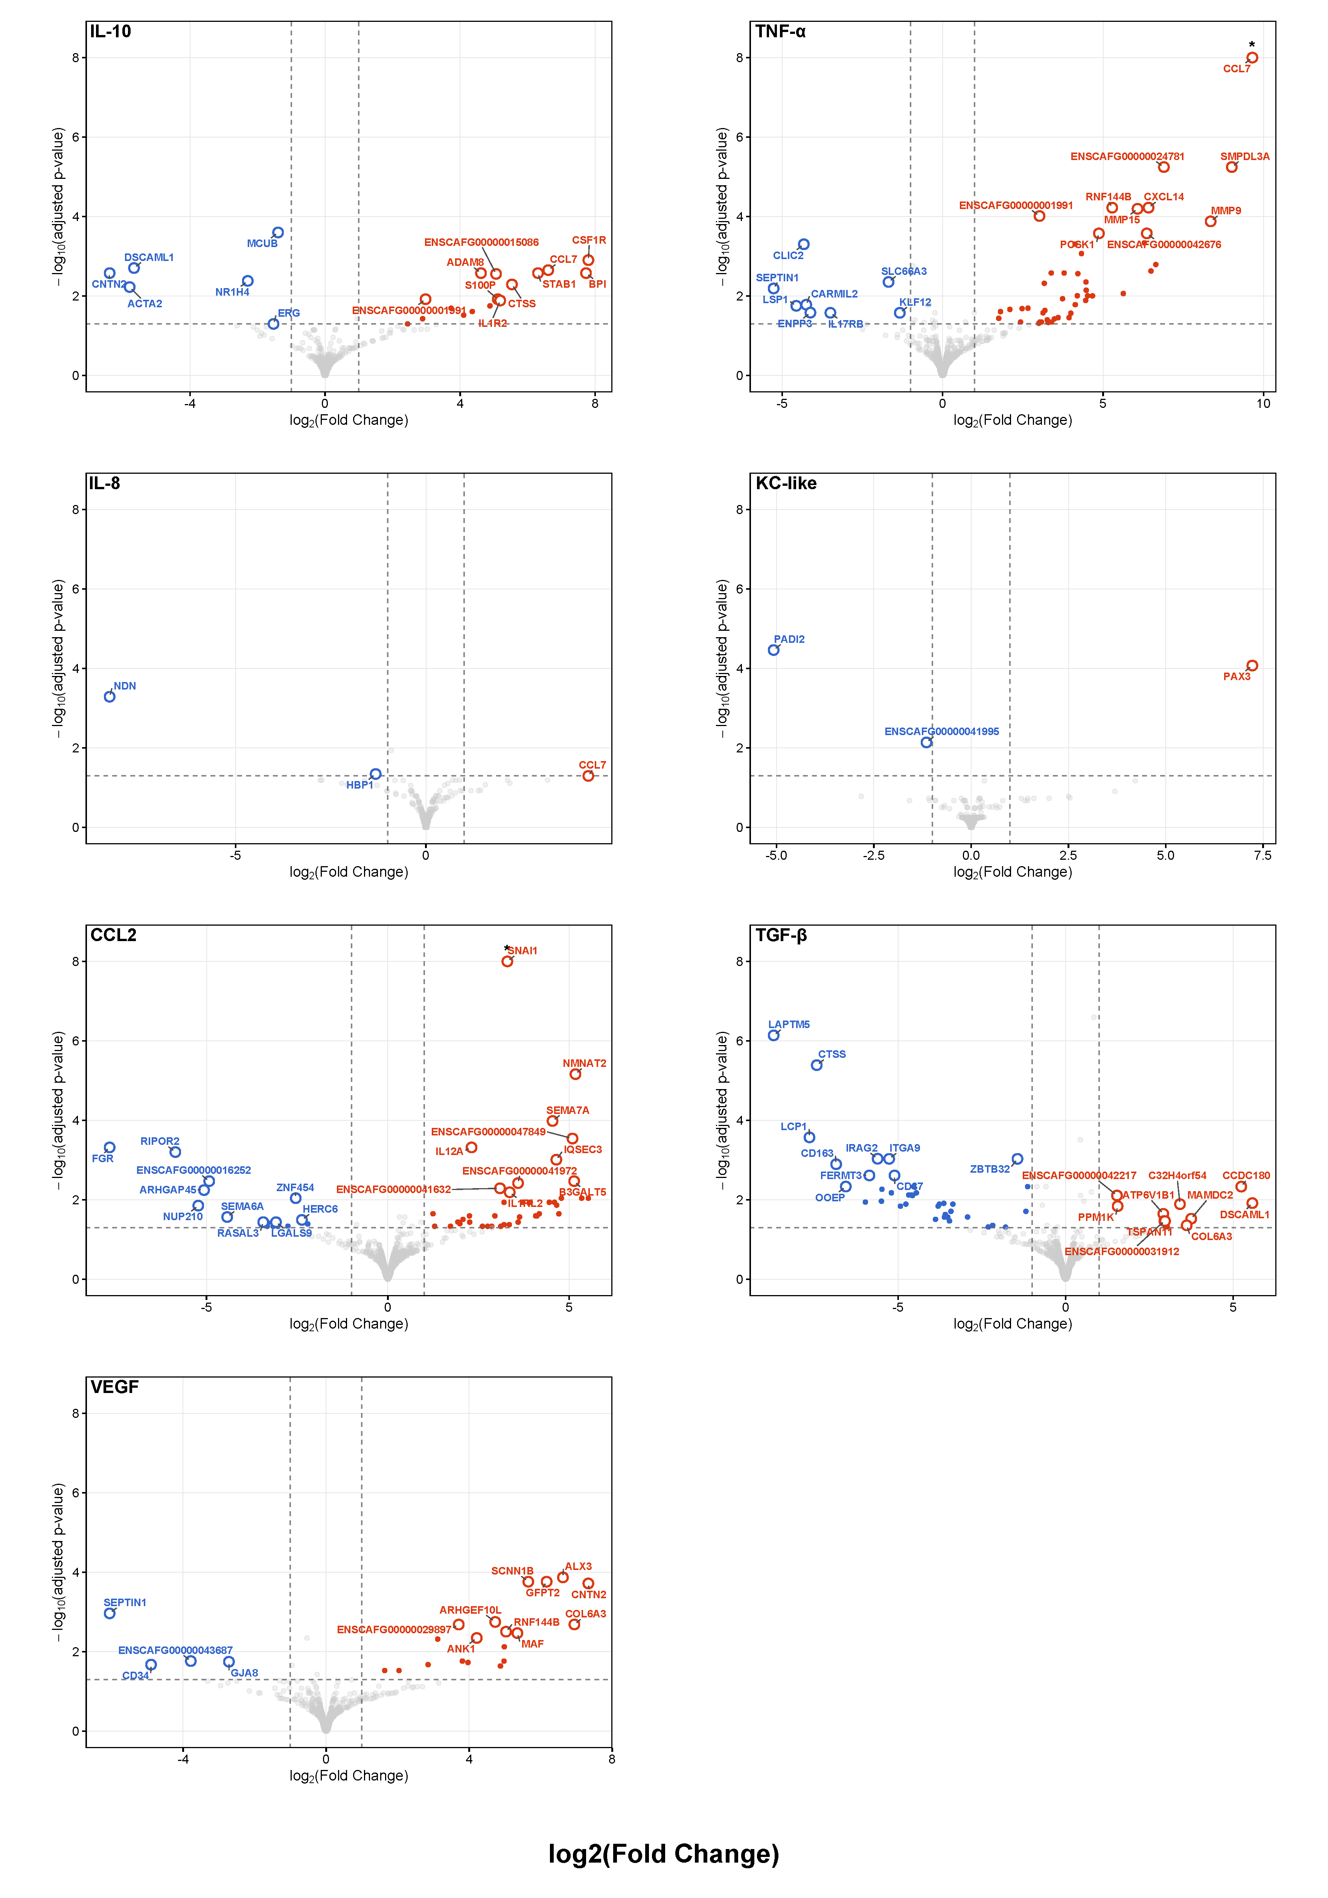

Figure 4: Volcano plots of DEGs in pairwise analysis. In each panel, the x-axis shows the shrunken log₂ fold-change and the y-axis shows –log₁₀ of the Benjamini–Hochberg–adjusted p-value. Dashed lines at ±1 log₂ fold change (FC) and FDR = 0.05 indicate the significance thresholds. Genes with |shrunken log₂FC| ≥ 1 and FDR ≤ 0.05 are colored red (up-regulated) or blue (down-regulated); all others are shown in gray. An asterisk marks a value that exceeds the plotted range. The top 10 most significant up- and down-regulated genes (ranked by adjusted p-value and effect size) are labeled.

We then performed GSEA with the gene lists from the pairwise analysis based on pre-ranked log2foldchange values using MsigDB’s hallmark, C2, C6, and C7 collections. The high-stimulator groups showed enrichment for epithelial-to-mesenchymal transformation (CCL2, VEGF), immune suppression (CCL2, TGF-β, VEGF), MEK signaling (IL-8), macrophage response/activation (CCL2, IL-10, TNF-α), extracellular matrix remodeling (TNF-α, VEGF) and suppression of IL-2 signaling (TNF-α). A selection of relevant enriched gene sets is shown in Supplementary Figure 5. All gene sets are provided in Supplementary Table 7.
Cell lines with upregulated MVB12A had the strongest ability to stimulate VEGF from macrophages.
We validated our RNA-seq correlation findings suggesting that MVB12A expression in cancer cell lines is associated with stimulation of VEGF secretion from primary macrophages. MVB12A encodes a subunit of ESCRT-I, which is involved in exosomal cargo sorting, leading us to investigate whether exosomes mediate macrophage response.²⁷ We first measured VEGF levels in the TCM from 7 of the top VEGF-stimulating cell lines (Jones, MacKinley, Nike, OS2.4 OSA8, Parks and STS-1). TCM VEGF production was not significantly correlated with macrophage VEGF induction (mixed-effects model, p = 0.397). As described in the Methods section, we then fractionated TCM from these 7 cell lines into whole, exosome-depleted, and exosome-only conditions. Macrophages treated with the exosome-only fraction secreted significantly more VEGF than those treated with whole or exosome-depleted TCM (mixed-effects model accounting for cell line and donor variability) (Figure 5A). We also analyzed each of the 7 cell lines individually using mixed-effects models with donor as a random effect. Post-hoc pairwise comparisons identified that the exosome-only condition stimulated significantly higher VEGF levels than whole TCM in all cells line except OS2.4. To further validate this finding, we generated fresh TCM from eight cell lines, four used in the original experiment (Parks, Nike, 1771 and CLL-1390) and four newly selected (CIN, SB, Angus, and Tyler) based on MVB12A expression. Seven of the eight cell lines stimulated macrophages as predicted (i.e., TCM from cell lines with high MVB12A stimulated high VEGF). When all eight cell lines were analyzed, the difference in VEGF stimulation between high- and low-MVB12A groups was not significant (p = 0.13). However, CIN, a hemangiosarcoma (HSA) cell line, showed unexpectedly low VEGF stimulation despite high MVB12A expression. Excluding CIN as a potential biological outlier, the remaining cell lines showed a significant difference in VEGF stimulation on Welch’s t-test between high- and low-MVB12A groups (p = 0.0098) (Figures 5B and C). To determine whether the exosomes carried VEGF themselves or stimulated VEGF through an alternative mechanism, TCM aliquots from the eight cell lines from Figure 5B were again depleted of exosomes, resulting in an aliquot of exosome-depleted TCM and an aliquot of concentrated exosomes (brought to equal volume). A comparison of VEGF concentrations in the lysed concentrated exosomes and exosome-depleted fractions revealed that all MVB12A-high cell lines, including CIN, had a significantly higher ratio of VEGF in the lysed exosome fraction, consistent with exosome-associated VEGF cargo (Figure 5D). Finally, in Parks and Angus (two high-MVB12A high-stimulator lines), we compared VEGF in non-lysed concentrated exosome fraction to exosome-depleted TCM in the same manner as above (except that exosomes were not lysed). The presumed exosome-associated to non-exosome associated VEGF ratio fell sharply (Parks: 17.7x to 5.8x; Angus: 7.0x to 1.3x), suggesting that a substantial fraction of VEGF is packaged inside exosomes rather than merely co-isolated with them. Further studies using more rigorous methods to isolate exosomes are required to confirm these findings. No dose-response relationship was observed between the number of exosomes and VEGF stimulation in any of the experiments conducted (data not shown).
Figure 5: Validation of MVB12A’s role in exosome-associated VEGF stimulation. (A) VEGF secretion by macrophages after treatment with whole tumor-conditioned media (TCM), exosome-deplete TCM, and exosome-only media, n=3 donors (averaged) and 7 cell lines per condition. (B) VEGF secretion from macrophages incubated with TCM derived from high- versus low-MVB12A cell lines, n=3 donors. Significance bracket excludes CIN due to atypical behavior (p = 0.0089, Welch's t-test; see text). (C) RUVg-normalized counts of MVB12A expression across all cell lines. For (B) and (C), colors indicate high (purple) and low (blue) expressors; darker shades denote the discovery set, lighter shades the validation set. (D) Ratio of presumed exosome-associated to free VEGF in the 7 high- vs. low-MVB12A lines from (B) and (C) (p = 0.032, Student’s t-test). Data shown are mean +/- standard error of the mean (SEM).

Cell lines with CCL3 upregulated stimulated high levels of TNF-α from macrophages.
Preliminary inspection of pairwise analysis performed on unfiltered RNA-seq data revealed that only two histiocytic sarcoma (HS) cell lines (DH82 and Nike) expressed high levels of CCL3, which was positively associated with high levels of TNF-α secretion from macrophages (adj p-value = 5.93E-14, log2FC = 24.92). CCL3, also known as macrophage inflammatory protein 1α, induces the recruitment of myeloid cells and facilitates T-cell responses in the TME.³⁰ These data were ultimately filtered out because of the requirement that a gene count be present in at least six of the 12 samples used for pairwise analysis. However, because these two cell lines originated from the same tumor type, we further investigated the involvement of CCL3 in the stimulation of TNF-α by macrophages in a mechanism potentially unique to HS. Upon examination of multiple publicly available RNA-seq datasets, we observed that CCL3 is broadly expressed in canine HS tumors and cell lines. In 11 primary canine HS samples, 10 had detectable CCL3 mRNA; similarly, 10 of 12 canine HS cell lines were CCL3 positive, one of which was DH82. Investigators at the FACC also shared unpublished data from 12 canine HS tumors from the FACC tumor biorepository, and all 12 analyzed were positive for CCL3 (S. Beeson and D. Duval, personal communication). RNA-seq analysis from an expanded FACC panel comprising 42 cell lines of various tumor types, including the cell lines originally used in this experiment, showed that only four cell lines had measurable CCL3 transcripts. These included the two HS cell lines we identified (DH82 and Nike) and two other hematopoietic tumors (BRMCT, mast cell tumor and CLBL1, B-cell lymphoma) (S. Das and D. Duval, personal communication). Taken together, these results indicate that CCL3 expression is common in canine HS and may be unique to hematopoietic tumors.
We first measured CCL3 levels in all the TCM generated. As expected, DH82 and Nike secreted the highest amount of CCL3. Surprisingly, several other cell lines had low concentrations of secreted CCL3, which was not captured at the transcript level in the RNA-seq data (Figure 6A). We replicated these findings using recombinant canine CCL3, showing that recombinant CCL3 caused a dose-dependent increase in TNF-α secretion from macrophages. These results were adjusted for relative cell counts, as more macrophages were detached by visual inspection at higher CCL3 concentrations (Figure 6B). CCL3 knockdown was confirmed at approximately 50% efficiency in KD-DH82 cells (Supplementary Figure 6). Macrophages treated with both KD-DH82 and NTC-DH82 TCM showed a significant reduction in TNF-α secretion compared with WT-DH82 TCM. Although the reduction induced by NTC-DH82 TCM was of a lesser magnitude (76% vs 82% from KD-DH82 TCM), there was no statistically significant difference between these treatments. Due to the small sample size, this could indicate both specific and non-specific effects of CCL3 knockdown but would require further validation. (Figure 6C).
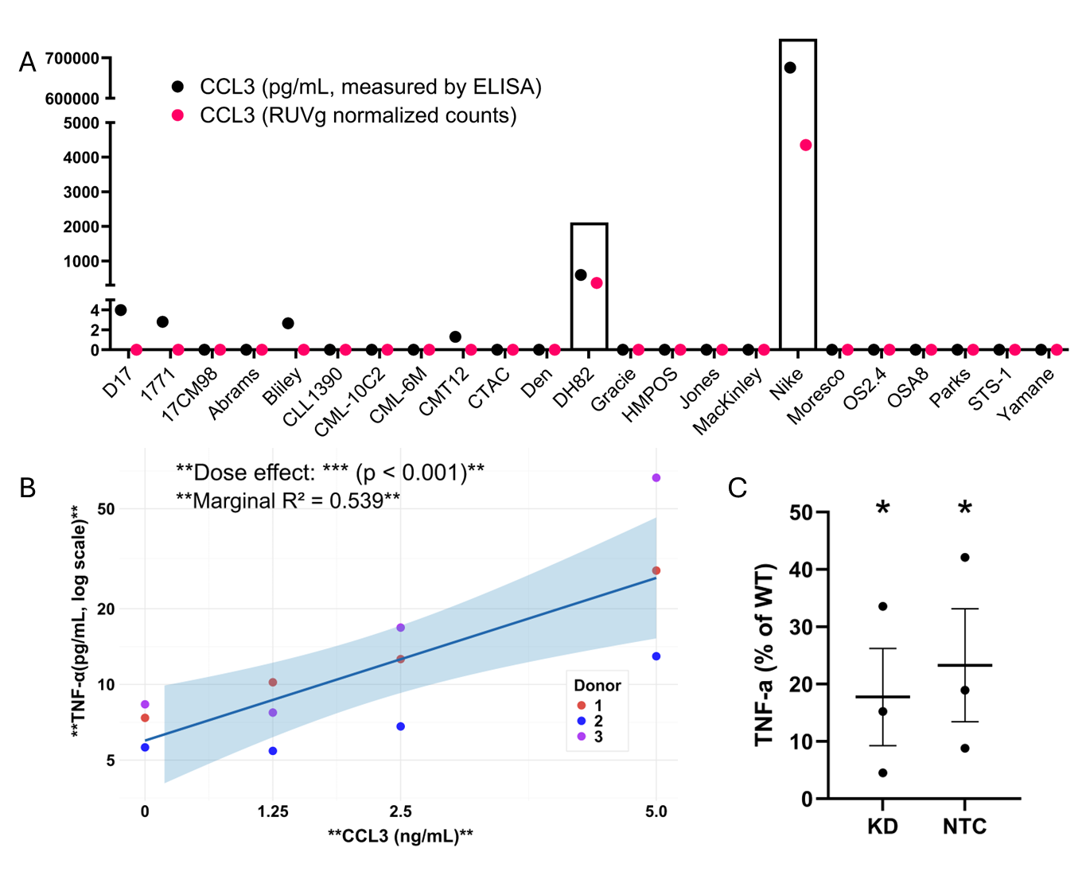
Figure 6: CCL3‐induced TNF-α secretion by macrophages. (A) CCL3 protein (black) and mRNA (magenta) levels in tumor-conditioned media from multiple cell lines. DH82 and Nike exhibit the highest transcript and secreted protein, whereas some lines show low protein levels despite undetectable mRNA. (B) Dose-dependent TNF-α secretion by primary macrophages in response to recombinant CCL3 (0–5 ng/mL). Linear mixed-effects modeling with donor as random effect revealed a significant dose effect (p < 0.001, marginal R² = 0.539), (n = 3 donors, 4 doses each). (C) Both non-targeting control (NTC) and CCL3 knockdown (KD) DH82-conditioned media significantly reduced macrophage TNF-α secretion compared to wildtype baseline (*p < 0.05), with KD showing numerically lower levels than NTC (n = 3 donors).

DISCUSSION
This study tested two main hypotheses: that canine tumor cell lines would differ in their ability to polarize macrophages regardless of original tumor type, and that the cell lines that polarized macrophages most strongly would have relevant gene expression profiles. This study was undertaken because the TME remains a significant barrier to successful therapy and is complicated by its significant variability between and within tumor type. Therefore, TME-based biomarkers could be useful for stratifying patients for TME-based therapies. In this study, we measured the ability of cancer cell lines to stimulate immunomodulatory cytokines in primary macrophages as a simplified proxy for in vivo cancer cell – macrophage crosstalk and correlated this information with the transcriptome of cancer cells.
We focused on macrophage-secreted cytokines as markers of an “active” TME, rather than strict M1/M2 indicators. In our study, VEGF, TNF-α, IL-10, TGF-β, IL-8, CCL2, and KC-like showed significant variability between cell lines and are all known major players in the TME.^{31–33} VEGF drives tumor angiogenesis and tumor cell survival, TGF-β promotes epithelial-to-mesenchymal transition, matrix remodeling, and immune cell exclusion, and CCL2 recruits immunosuppressive monocytes, myeloid-derived suppressor cells, and T-regulatory cells to the TME^{33–35}. We found that IL-8 and KC-like protein levels were moderately correlated. Together, these have been shown to recruit multiple subsets of immunosuppressive myeloid cells to the TME^{31,36}. IL-10 and TNF-α were strongly correlated, supporting their known feedback in balancing pro- and anti-inflammatory signaling³⁷. These cytokine patterns help to illustrate the complexity of determining how an individual tumor may maintain its TME. While we largely concentrated on TCM that drove high secretions, several cell lines actively repressed certain cytokines compared to unstimulated (M0) macrophages. This was observed most strikingly in VEGF and CCL2. The observed suppression patterns warrant follow-up functional assays to clarify these pathways further. DEG and GSEA analysis revealed cytokine-specific enrichment patterns, with CCL2/VEGF linked to EMT and immune suppression, TNF-α to matrix remodeling, and IL-8 to MEK signaling. There was also shared upregulation of macrophage activation and regulation genes across several cytokines. Further research is needed to establish the mechanistic links between the secreted cytokines and these genomic patterns.
To examine the mechanistic link in one example case, we identified MVB12A as a DEG that is strongly associated with VEGF secretion from polarized macrophages. Since MVB12A is a critical protein for loading cargo into exosomes, we performed an exosome-enrichment assay. Macrophages incubated with the purified exosome fraction secreted significantly more VEGF than those treated with whole or exosome-depleted TCM. This suggests that an inhibitory factor in unfractionated TCM may counteract the exosome-driven VEGF stimulation via regulation of exosome uptake, fusion, or cargo release. Dissecting which mechanisms operate in TCM would provide valuable insights into the control of governing VEGF and exosome by tumor cells. The similar VEGF levels found between unfractionated TCM and exosome-deplete TCM may be due to other soluble factors in the exosome-deplete supernatant that independently stimulate VEGF. We also preliminarily explored how exosomes control VEGF release from macrophages. Possible hypotheses include the direct carriage of VEGF protein within exosomes (which is then released upon phagocytosis), delivery of upstream regulators (e.g., microRNA-21) that induce VEGF transcription, or broad reprogramming of macrophages towards an M2-like state, indirectly boosting VEGF secretion.^{38,39} Although lysis of the exosome fraction led to a significantly higher measured VEGF concentration (most consistent with direct carriage), we cannot fully exclude the possibility of co-isolation of VEGF bound to contaminating proteins. These findings warrant further investigation with larger sample sizes and more comprehensive depletion methods to clarify the relative contributions of exosomal versus soluble VEGF-stimulating factors, and to confirm how exosomes stimulate VEGF release from macrophages.
We also confirmed that three of the four MVB12A-high cell lines stimulated high VEGF release in an exosome-dependent manner. The exception was the HSA cell line CIN, which showed high MVB12A expression, but stimulated low VEGF levels. All MVB12A-high lines, including CIN, showed VEGF enrichment in exosomes as compared to free VEGF, suggesting that CIN-derived exosomes may interact differently with macrophages. Interestingly, another HSA cell line, SB, was among the low stimulators of VEGF (with low MVB12A expression), which could reflect a tumor type-specific adaptation. Despite high levels of secreted VEGF, canine HSA cells are insensitive to VEGF-induced proliferation.⁴⁰ Therefore, it is possible that these cells derive little additional benefit from the VEGF secreted by macrophages. HSA tumors can also use alternative angiogenic pathways such as fibroblast growth factor 2, which can reduce VEGF secretion.⁴¹ Human angiosarcoma, a comparable malignancy, has documented mutations that result in ligand-independent constitutive VEGF receptor signaling, potentially reducing the reliance on secreted VEGF.⁴²
A significant Spearman’s correlation was also found between high TRAPPC5 expression and VEGF secretion. TRAPPC5 is a key subunit of the TRAPP complex that is involved in ER-to-Golgi vesicular trafficking.²⁸ This suggests that the general vesicle-transport machinery, and not just ESCRT-mediated exosome release, could regulate VEGF delivery. TRAPPC5’s role in VEGF stimulation requires further investigation.
Although our efforts largely focused on tumor type-agnostic findings, we identified another gene, CCL3, whose upregulation correlated with TNF-α secretion from macrophages only in HS cell lines. HS is a rare malignancy with a grave prognosis in both humans and dogs. With no accepted standard of care, there is a distinct need for better therapies for this cancer.^{43,44} We demonstrated that the two HS cell lines with upregulated CCL3 stimulated significantly higher relative TNF-α secretion from the macrophages. We also found that CCL3 expression, which is common in canine HS, did not commonly appear in non-hematopoietic tumor types. The mechanism by which upregulated CCL3 drives TNF-α production was not determined in this study. The simplest explanation is that secreted CCL3 directly binds to its receptor CCR1/CCR5 on macrophages, triggering downstream mitogen-activated kinase (MAPK) or NF-κB signaling, which upregulates TNF-α gene transcription.⁴⁵ Alternatively, CCL3 could stimulate the release of an unknown intermediary cytokine, which in turn stimulates TNF-α. CCL3 is commonly recognized as a strong chemoattractant for myeloid cells and an enhancer of T cell responses. However, chronic TNF-α stimulation can drive immune exhaustion.^{30,46} Disrupting the CCL3-signaling axis or modulating downstream TNF-α could improve anti-tumor immunity. Therapies that boost CCL3 at the tumor site are already being investigated to improve T cell and checkpoint inhibitor responses.³⁰ Further work is needed to better understand how tumors high in CCL3 are affected by CCL3 knockout and whether TNF-α modulation supports their progression differently than in CCL3-low tumors.
The main limitation of this study was that the in vitro system based on TCM and monocyte-derived macrophage cultures does not match the biological complexity of the TME in vivo. The TME comprises evolving metabolic, spatial, and temporal heterogeneity, in which macrophages dynamically interact with stromal cells, other immune cells, and cancer cells. Another limitation was that the multiplex bead-based assay and the individual ELISAs had differing sensitivities and dynamic ranges. Therefore, comparison of the absolute values of different analytes in this study is not recommended. Additionally, we excluded analytes for which most values were below the lower limit of quantification (LLoQ). Analysis of these analytes could have been attempted using median fluorescence intensity (MFI) values instead of absolute concentrations. We chose not to pursue this because the manufacturer did not validate the interpretation of the MFI values below the LLoQ. However, this may have provided additional relevant hypotheses for future research. Future studies with higher-sensitivity assays or pre-enrichment strategies may allow for a more meaningful interpretation of these cytokines. Furthermore, our study evaluated only the relationship between cell line transcriptome data and macrophage secretory products. We did not establish direct connections between the secreted proteins in TCM and the macrophage secretory products. The measurement of secreted proteins may not always match the mRNA levels because of post-transcriptional regulation among other mechanisms. This was demonstrated by our observation of CCL3 protein secretion despite undetectable transcript levels in some cell lines. Future research combining proteomic TCM analysis with macrophage phenotyping would establish more mechanistic connections between tumor-secreted factors and macrophage polarization outcomes. Finally, the current sample size of 25 cell lines, together with a small number of donor specimens, enabled proof-of-concept validation. However, future studies are needed to truly understand the diversity among cancer patients, as evidenced by our analysis of inter-donor variability. Our current sample size was also too small to determine if the disease process in donors impacted macrophage responses, and this should also be investigated in future studies.
CONCLUSIONS
In summary, previous attempts at TME subtyping using single-cell RNA-seq have provided important information regarding multiple TAM states in human tumors.^{3,4} Our approach builds on this by tracking functional secretory outputs following TCM exposure to provide different phenotypic measurements of tumor cell signals. The method of measuring active cytokine release from macrophages complements static gene expression analyses. Although this study used canine models, its relevance to human cancer immunology is highlighted by the conservation of many cross-species immune pathways and prior success in translational drug development.^{17,18,47} A combination of secretory profiling and transcriptomic subtyping could be used in human models to develop patient stratification tools by evaluating both the molecular and functional aspects of TAM heterogeneity. The National Cancer Institute-Molecular Analysis for Therapy Choice (MATCH) trial (NCT02465060) demonstrated the utility of molecular profiling to assign patients to targeted therapies in a tumor-agnostic manner. The study reached its signal-seeking goal when 25.9% of the treatment arms met their predetermined response rate threshold, and researchers have initiated a follow-up study with matched immunotherapies.⁴⁸ The inclusion of biomarkers such as MVB12A or CCL3 expression in prospective trials could enable the identification of patients needing therapies targeting the VEGF pathway, exosome biogenesis, or cytokine modulation. Testing this platform further in murine and additional canine models, and eventually translating it into human systems, will reveal whether it can improve patient stratification strategies for TME-centric therapies.

References
1. de Visser KE, Joyce JA. The evolving tumor microenvironment: From cancer initiation to metastatic outgrowth. Cancer Cell. 2023;41(3):374-403. doi:10.1016/J.CCELL.2023.02.016
2. Xiao Y, Yu D. Tumor microenvironment as a therapeutic target in cancer. Pharmacol Ther. 2020;221:107753. doi:10.1016/J.PHARMTHERA.2020.107753
3. Nieto P, Elosua-Bayes M, Trincado JL, et al. A single-cell tumor immune atlas for precision oncology. Genome Res. 2021;31(10):1913-1926. doi:10.1101/GR.273300.120
4. Cheng S, Li Z, Gao R, et al. A pan-cancer single-cell transcriptional atlas of tumor infiltrating myeloid cells. Cell. 2021;184(3):792-809.e23. doi:10.1016/J.CELL.2021.01.010
5. Emens LA, Romero PJ, Anderson AC, et al. Challenges and opportunities in cancer immunotherapy: a Society for Immunotherapy of Cancer (SITC) strategic vision. J Immunother Cancer. 2024;12(6):e009063. doi:10.1136/JITC-2024-009063
6. Huang AC, Zappasodi R. A decade of checkpoint blockade immunotherapy in melanoma: understanding the molecular basis for immune sensitivity and resistance. Nat Immunol. 2022;23(5):660-670. doi:10.1038/S41590-022-01141-1
7. Stanley R, Flanagan S, Reilly DO, Kearney E, Naidoo J, Dowling CM. Immunotherapy through the Lens of Non-Small Cell Lung Cancer. Cancers (Basel). 2023;15(11):2996. doi:10.3390/CANCERS15112996
8. Lin Z, Huang L, Li SL, Gu J, Cui X, Zhou Y. PTEN loss correlates with T cell exclusion across human cancers. BMC Cancer. 2021;21(1). doi:10.1186/S12885-021-08114-X
9. Zhang C, Liu J, Xu D, Zhang T, Hu W, Feng Z. Gain-of-function mutant p53 in cancer progression and therapy. J Mol Cell Biol. 2020;12(9):674-687. doi:10.1093/JMCB/MJAA040
10. Ringel AE, Drijvers JM, Baker GJ, et al. Obesity shapes metabolism in the tumor microenvironment to suppress anti-tumor immunity. Cell. 2020;183(7):1848. doi:10.1016/J.CELL.2020.11.009
11. Zhou Z, Wei JH, Jiang W. Characterization of aging tumor microenvironment with drawing implications in predicting the prognosis and immunotherapy response in low-grade gliomas. Scientific Reports 2022 12:1. 2022;12(1):1-16. doi:10.1038/s41598-022-09549-3
12. Chen X, Ma Z, Yi Z, et al. The effects of metabolism on the immune microenvironment in colorectal cancer. Cell Death Discov. 2024;10(1). doi:10.1038/S41420-024-01865-Z
13. Yang J, Xu J, Wang W, Zhang B, Yu X, Shi S. Epigenetic regulation in the tumor microenvironment: molecular mechanisms and therapeutic targets. Signal Transduct Target Ther. 2023;8(1):210. doi:10.1038/S41392-023-01480-X
14. Huang J, Zhang J, Guo Z, et al. Easy or Not—The Advances of EZH2 in Regulating T Cell Development, Differentiation, and Activation in Antitumor Immunity. Front Immunol. 2021;12:741302. doi:10.3389/FIMMU.2021.741302
15. Kzhyshkowska J, Shen J, Larionova I. Targeting of TAMs: can we be more clever than cancer cells? Cellular & Molecular Immunology 2024 21:12. 2024;21(12):1376-1409. doi:10.1038/s41423-024-01232-z
16. Brady R V, Thamm DH. Tumor-associated macrophages: Prognostic and therapeutic targets for cancer in humans and dogs. Published online 2023. doi:10.3389/fimmu.2023.1176807
17. Klosowski M, Haines L, Alfino L, McMellen A, Leibowitz M, Regan D. Naturally occurring canine sarcomas: Bridging the gap from mouse models to human patients through cross-disciplinary research partnerships. Front Oncol. 2023;13. doi:10.3389/FONC.2023.1130215
18. Felsburg PJ. Overview of immune system development in the dog: comparison with humans. http://dx.doi.org/101191/0960327102ht286oa. 2002;21(9-10):487-492. doi:10.1191/0960327102HT286OA
19. Leblanc AK, Mazcko CN, Khanna C. Defining the Value of a Comparative Approach to Cancer Drug Development. Clin Cancer Res. 2016;22(9):2133-2138. doi:10.1158/1078-0432.CCR-15-2347
20. Williams HL, Frei AL, Koessler T, et al. The current landscape of spatial biomarkers for prediction of response to immune checkpoint inhibition. NPJ Precis Oncol. 2024;8(1):1-18. doi:10.1038/S41698-024-00671-1;SUBJMETA=1059,1857,2325,631,67;KWRD=CANCER+IMMUNOTHERAPY,TUMOUR+BIOMARKERS
21. O’Donoghue LE, Rivest JP, Duval DL. Polymerase chain reaction-based species verification and microsatellite analysis for canine cell line validation. J Vet Diagn Invest. 2011;23(4):780-785. doi:10.1177/1040638711408064
22. Volume 16: How to Detect and Handle Outliers.
23. Das S, Idate R, Cronise KE, Gustafson DL, Duval DL. Identifying Candidate Druggable Targets in Canine Cancer Cell Lines Using Whole-Exome Sequencing. Mol Cancer Ther. 2019;18(8):1460-1471. doi:10.1158/1535-7163.MCT-18-1346
24. Farrell KB, Das S, Nordeen SK, Lambert JR, Thamm DH. VDX-111 targets proliferative pathways in canine cancer cell lines. PLoS One. 2024;19(5):e0303470. doi:10.1371/JOURNAL.PONE.0303470
25. Zeng Y, Du X, Jiang W, Qiu Y. Measurement of VEGF Content in Exosomes and Subsequent Tumor Tubulogenesis and In Vivo Angiogenesis Functional Assays. Methods in Molecular Biology. 2022;2475:79-96. doi:10.1007/978-1-0716-2217-9_5,
26. Team RC. R Core Team 2023 R: A language and environment for statistical computing. R foundation for statistical computing. https://www.R-project.org/. R Foundation for Statistical Computing. Published online 2023.
27. Tsunematsu T, Yamauchi E, Shibata H, Maki M, Ohta T, Konishi H. Distinct functions of human MVB12A and MVB12B in the ESCRT-I dependent on their posttranslational modifications. Biochem Biophys Res Commun. 2010;399(2):232-237. doi:10.1016/J.BBRC.2010.07.060
28. Zappa F, Wilson C, Tullio G Di, et al. The TRAPP complex mediates secretion arrest induced by stress granule assembly. EMBO J. 2019;38(19):e101704. doi:10.15252/EMBJ.2019101704
29. Seal RL, Braschi B, Gray K, et al. Genenames.org: the HGNC resources in 2023. Nucleic Acids Res. 2023;51(D1):D1003-D1009. doi:10.1093/NAR/GKAC888
30. Kang TG, Park HJ, Moon J, Lee JH, Ha SJ. Enriching CCL3 in the Tumor Microenvironment Facilitates T cell Responses and Improves the Efficacy of Anti-PD-1 Therapy. Immune Netw. 2021;21(3):e23. doi:10.4110/IN.2021.21.E23
31. Korbecki J, Bosiacki M, Barczak K, et al. Involvement in Tumorigenesis and Clinical Significance of CXCL1 in Reproductive Cancers: Breast Cancer, Cervical Cancer, Endometrial Cancer, Ovarian Cancer and Prostate Cancer. Int J Mol Sci. 2023;24(8):7262. doi:10.3390/IJMS24087262
32. Kartikasari AER, Huertas CS, Mitchell A, Plebanski M. Tumor-Induced Inflammatory Cytokines and the Emerging Diagnostic Devices for Cancer Detection and Prognosis. Front Oncol. 2021;11:692142. doi:10.3389/FONC.2021.692142/XML/NLM
33. Kadomoto S, Izumi K, Mizokami A. Roles of CCL2-CCR2 Axis in the Tumor Microenvironment. Int J Mol Sci. 2021;22(16):8530. doi:10.3390/IJMS22168530
34. Wang X, Eichhorn PJA, Thiery JP. TGF-β, EMT, and resistance to anti-cancer treatment. Semin Cancer Biol. 2023;97:1-11. doi:10.1016/J.SEMCANCER.2023.10.004
35. Patel SA, Nilsson MB, Le X, Cascone T, Jain RK, Heymach J V. Molecular Mechanisms and Future Implications of VEGF/VEGFR in Cancer Therapy. Clin Cancer Res. 2023;29(1):30. doi:10.1158/1078-0432.CCR-22-1366
36. Rizzo M, Varnier L, Pezzicoli G, Pirovano M, Cosmai L, Porta C. IL-8 and its role as a potential biomarker of resistance to anti-angiogenic agents and immune checkpoint inhibitors in metastatic renal cell carcinoma. Front Oncol. 2022;12:990568. doi:10.3389/FONC.2022.990568/BIBTEX
37. Goswami B, Rajappa M, Mallika V, Kumar Shukla D, Kumar S. TNF-α/IL-10 ratio and C-reactive protein as markers of the inflammatory response in CAD-prone North Indian patients with acute myocardial infarction. Published online 2009. doi:10.1016/j.cca.2009.06.029
38. Saadh MJ, Jasim NY, Ahmed MH, et al. Critical roles of miR-21 in promotions angiogenesis: friend or foe? Clinical and Experimental Medicine 2025 25:1. 2025;25(1):1-23. doi:10.1007/S10238-025-01600-7
39. Deng C, Huo M, Chu H, et al. Exosome circATP8A1 induces macrophage M2 polarization by regulating the miR-1-3p/STAT6 axis to promote gastric cancer progression. Mol Cancer. 2024;23(1):1-19. doi:10.1186/S12943-024-01966-4/FIGURES/8
40. Adachi M, Hoshino Y, Izumi Y, Sakai H, Takagi S. Effects of inhibitors of vascular endothelial growth factor receptor 2 and downstream pathways of receptor tyrosine kinases involving phosphatidylinositol 3-kinase/Akt/mammalian target of rapamycin or mitogen-activated protein kinase in canine hemangiosarcoma cell lines. Canadian Journal of Veterinary Research. 2016;80(3):209. Accessed May 11, 2025. https://pmc.ncbi.nlm.nih.gov/articles/PMC4924555/
41. Kodama A, Sakai H, Matsuura S, et al. Establishment of canine hemangiosarcoma xenograft models expressing endothelial growth factors, their receptors, and angiogenesis-associated homeobox genes. BMC Cancer. 2009;9:363. doi:10.1186/1471-2407-9-363,
42. Benton A, Liu B, Gartenhaus LE, Hanna JA. Genomic landscape and preclinical models of angiosarcoma. Mol Oncol. 2024;19(4):965. doi:10.1002/1878-0261.13744
43. Hung YP, Qian X. Histiocytic Sarcoma. Arch Pathol Lab Med. 2020;144(5):650-654. doi:10.5858/ARPA.2018-0349-RS
44. Moore PF. Histiocytic Diseases. Vet Clin North Am Small Anim Pract. 2023;53(1):121-140. doi:10.1016/J.CVSM.2022.07.010
45. Shaheen ZR, Christmann BS, Stafford JD, Moran JM, Buller RML, Corbett JA. CCR5 is a required signaling receptor for macrophage expression of inflammatory genes in response to viral double-stranded RNA. Am J Physiol Regul Integr Comp Physiol. 2019;316(5):R525-R534. doi:10.1152/AJPREGU.00019.2019,
46. Gane JM, Stockley RA, Sapey E. TNF- α Autocrine Feedback Loops in Human Monocytes: The Pro- and Anti-Inflammatory Roles of the TNF- α Receptors Support the Concept of Selective TNFR1 Blockade in Vivo. J Immunol Res. 2016;2016. doi:10.1155/2016/1079851,
47. Gardner HL, Fenger JM, London CA. Dogs as a Model for Cancer. 4. Accessed August 16, 2023. https://pmc.ncbi.nlm.nih.gov/articles/PMC6314649/
48. O’Dwyer PJ, Gray RJ, Flaherty KT, et al. The NCI-MATCH trial: Lessons for precision oncology. Nat Med. 2023;29(6):1349. doi:10.1038/S41591-023-02379-4
49. Posit team. RStudio: Integrated Development Environment for R. Posit Software, PBC. Preprint posted online 2023.
50. Risso D, Ngai J, Speed TP, Dudoit S. Normalization of RNA-seq data using factor analysis of control genes or samples. Nature Biotechnology 2014 32:9. 2014;32(9):896-902. doi:10.1038/nbt.2931
51. Stephens M. False discovery rates: A new deal. Biostatistics. 2017;18(2):275-294. doi:10.1093/BIOSTATISTICS/KXW041,

